**2023-2024 Summer-School Registration/Consent Form**

**Summer-School Recovery Camp**

**Holmes County Consolidated School District**

May 20, 2024

Dear HCCSD Parents:

The Holmes County Consolidated School District (HCCSD) is writing this to inform you that registration for our Summer Recovery Camp is now open. **This letter is to inform you that your child is required to attend summer school in the Holmes County Consolidated School District based on his or her performance during the 2023-2024 school year**. Our goal is to provide quality programming for our students in a safe and healthy environment during the summer. **This program is an extension of learning time, and a continuation of the current school year to strengthen students in the areas where results indicate they may have a weakness**.

The District’s Summer Recovery Camp will provide additional time for students, beyond the school year, to help sustain and develop their academic and social skills. Students will be exposed to reading, language arts, mathematics, social studies, science, social skills instruction, and enrichment. Attendance does not guarantee advancement to the next grade level. **Students will be required to obtain mastery in their enrolled course.**

**The Summer-School Recovery Camp will operate daily, June 3-June 28, 2024, Monday through Friday**

**(7:30 am- 12:30 pm) at no cost to the student.** Attendance is mandatory; students should attend all classes for which they register. Failing to attend regularly will result in a student being removed from the program roster. *Free meals and transportation home will be provided for all participating students when in-person.*

All school rules are in effect during the summer-school programs (please refer to the Student Handbook available through our website). In order for your child to participate in the Summer-School Recovery Camp, you and the student must have a signed ***Registration/Consent Form*** and ***Student Contract***. (The *Student Contract* confirms you and your child’s understanding and agreement to the policies and procedures of the summer-school program). In exchange for all that is available to your students, we ask that students follow the rules of our program and participate actively in the classes they sign up for.

Please send or drop off the completed Registration/Consent Form and Student Contract to your local school upon completion*.* Once the registration form is received, you and the student(s) will receive their schedule. Again, thank you for your support and we hope that our program provides an added value to our students this school year. If you have any questions, please do not hesitate to contact the Site Coordinator at your child’s assigned home school.

Sincerely,

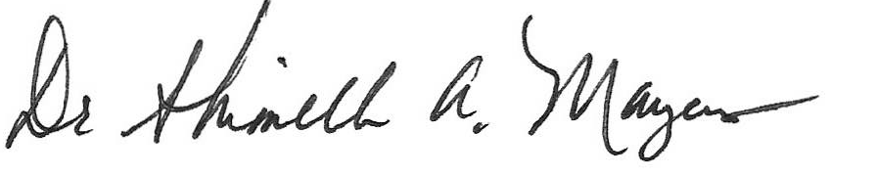

Dr. Shimelle Mayers, Assistant Superintendent of Academics

Holmes County Consolidated Schools

[smayers@holmesccsd.org](mailto:smayers@holmesccsd.org)

(o) 662-854-3448 ext. 1019

**2023-2024 Summer-School Registration/Consent Form**

**Summer-School Recovery Camp**

**Holmes County Consolidated School District**

*(Please complete and return to your child’s designated home school Prior to May 31, 2024*)

**Student’s Last Name:**_____________________________  **Student ID#:** ____________________

**Student’s First Name**: ____________________________ **Grade (June 2024):** _______________

**Street Address:**

**City:** ___________________________________________________ **Zip Code:**

**Phone:** __________________________ **Email Address:**

**Parent/Guardian Permission**

I hereby give permission for my son/daughter: __________________________________ to   
 (*please print name*)

participate in the Summer-School Recovery Camp, June 3-June 28, 2024. I understand students are required to obtain mastery in their enrolled courses. **And, attendance does not guarantee advancement to the next grade level.** I understand this FREE program will be held daily, Monday – Friday from 7:30 AM – 12:30 PM, and my child is expected to participate daily. Bus transportation will be provided to and from the program for in-person learning.

By signing this form, I also agree to support and encourage my son/daughter’s regular attendance to all programs in which he/she is enrolled.

**Parent/Guardian Name:**

**Signature:** _____________________________________________ **Date:**

**Emergency Contact:** _____________________________________________________________

**Contact Phone Number**:

***See Reverse Side***



**2023-2024 Summer-School Registration/Consent Form**

**Summer-School Recovery Camp**

**Holmes County Consolidated School District**

* All school rules and policies apply during the summer programs.
* Students are encouraged to attend the summer-school programs daily.

* Students are expected to attend the program in which they are enrolled; students may **not** attend programs in which they are not enrolled.
* Students must be on time for the start of each program period.
* Students identify themselves for each class both traditional and/or virtually.
* Students must be in their assigned area during program hours and may not leave campus at any time without a parent/guardian dismissal.
* Unacceptable behavior and failure to follow program rules (including on the school bus or virtually) may result in disciplinary action and possible dismissal from the program.

By signing below, I agree to comply with the rules above and understand that I may be dismissed from the program at any time, should I fail to follow the school rules.

**Print Name:** **Date:**

**Signature:** **Date:**

**Grade Level in September 2023:** _______